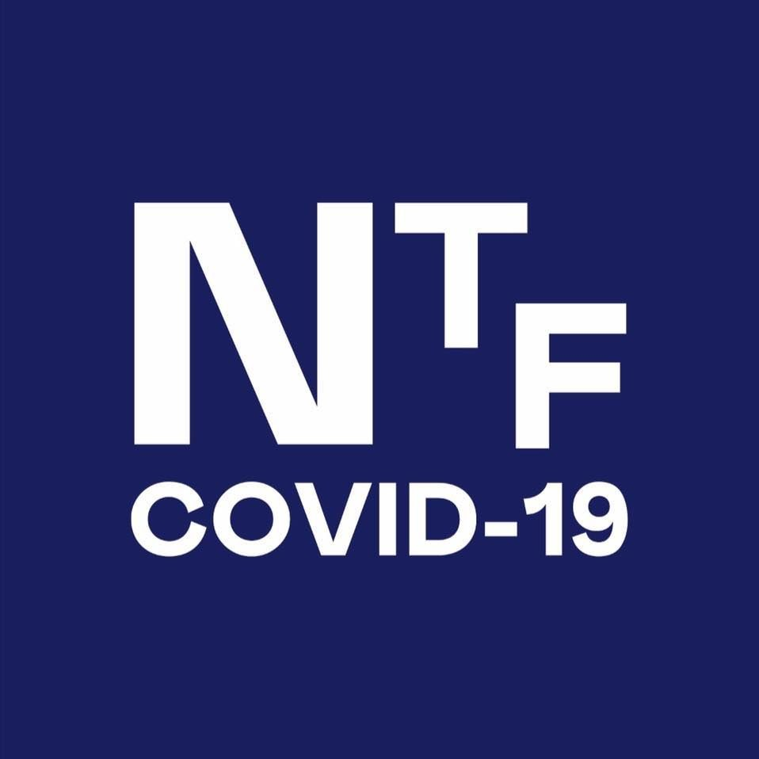INFORMED CONSENT FORM FOR THE SINOVAC COVID-19 VACCINE

*of the Philippine National COVID-19 Vaccine Deployment and Vaccination Program as of April 15, 2021*

|  |  |  |
| --- | --- | --- |
| **Name:**  **(LAST NAME, FIRST NAME, MIDDLE NAME)** | **Birthdate:** | **Sex:** |
| **Address:** | | |
| **Occupation:** | **Contact Number:** | |
| **Health facility:** | | |

**INFORMED CONSENT**

I conﬁrm that I have been provided with adequate information about SINOVAC COVID-19 vaccine, its Emergency Use Authorization from the Philippine Food and Drug Administration with advice for healthcare workers directly exposed to COVID-19 patients and those with comorbidities, and the recommendations of the interim National Immunization Technical Advisory Group (iNITAG) in the absence of any other vaccine to provide workers in frontline health services the autonomy to decide to be vaccinated with this speciﬁc batch of SINOVAC vaccines without prejudice to immediate eligibility for other vaccines. I have received suﬃcient information on the beneﬁts and risks of COVID-19 vaccines and I understand the possible risks if I am not vaccinated.

# I authorize releasing all information needed for public health purposes including reporting to applicable national vaccine registries, consistent with personal and health information storage protocols of the Data Privacy Act of 2012.

**I hereby give my consent to be vaccinated with the SINOVAC COVID-19 Vaccine.

I conﬁrm that I have been screened for health conditions that may merit deferment or special precautions during vaccination as indicated in the Health Screening Questionnaire.

**Signature over Printed Name**

Date

I was provided an opportunity to ask questions, all of which were adequately and clearly answered. I, therefore, voluntarily release the Government of the Philippines, the vaccine manufacturer, their agents and employees, as well as the hospital, the medical doctors and vaccinators, from all claims relating to the results of the use and administration of, or the ineffectiveness of the SINOVAC COVID-19 vaccine.

I understand that while most side effects are minor and resolve on their own, there is a small risk of severe adverse reactions, such as, but not limited to allergies, and that should prompt medical attention be

***In case eligible individual is unable to sign:***

# I have witnessed the accurate reading of the consent form and liability waiver to the eligible individual; suﬃcient information was given and queries raised were adequately answered. I hereby conﬁrm that he/she has given his/her consent to be vaccinated with the SINOVAC COVID-19 Vaccine.

needed, referral to the nearest hospital shall be provided immediately by the Government of the Philippines. I have been given contact information for

Signature over

Printed Name

Date

follow up for any symptoms I may experience after vaccination.

I understand that by signing this Form, I have a right to health beneﬁt packages under the Philippine Health Insurance Corporation (PhilHealth), in case I suffer a severe and/or serious adverse event, which is found to be associated with the SINOVAC COVID-19 vaccine or its administration. I understand that the right to claim compensation is subject to the guidelines of the PhilHealth.

|  |
| --- |
|  |
|  |
|  |
|  |
|  |

**If you chose not to get vaccinated, please list down your reason/s:**